EXPERIMENT – 12

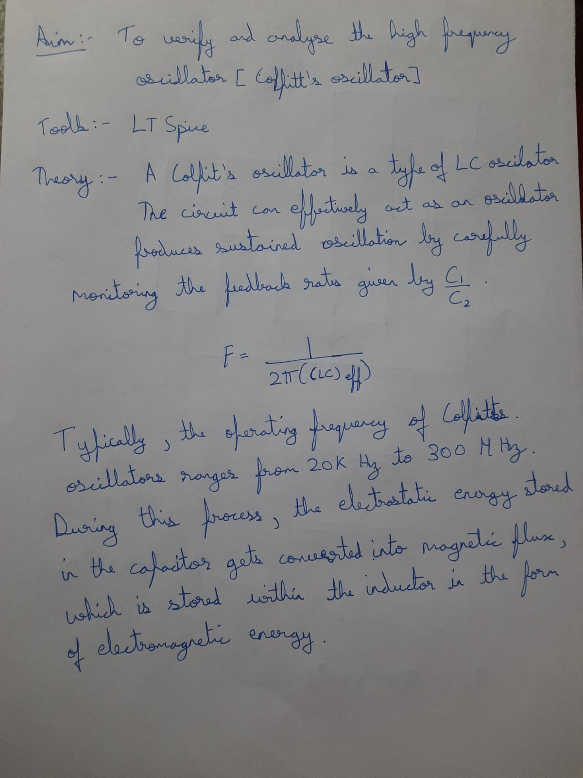

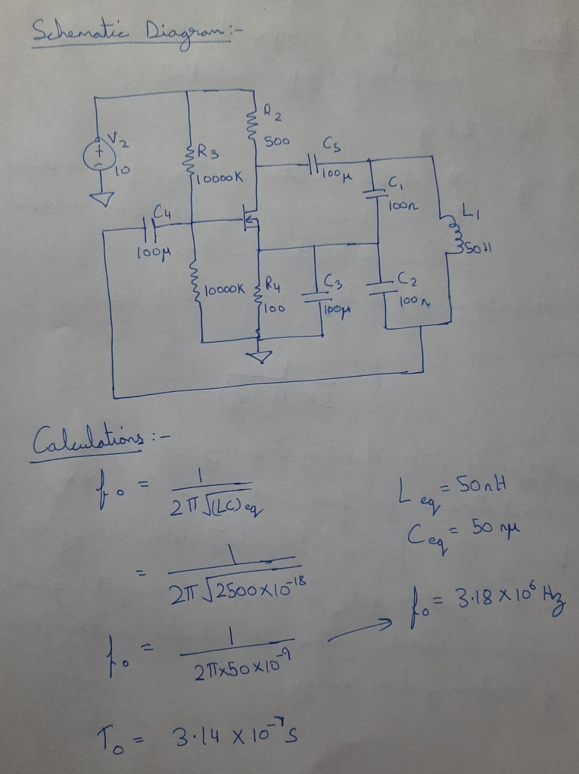

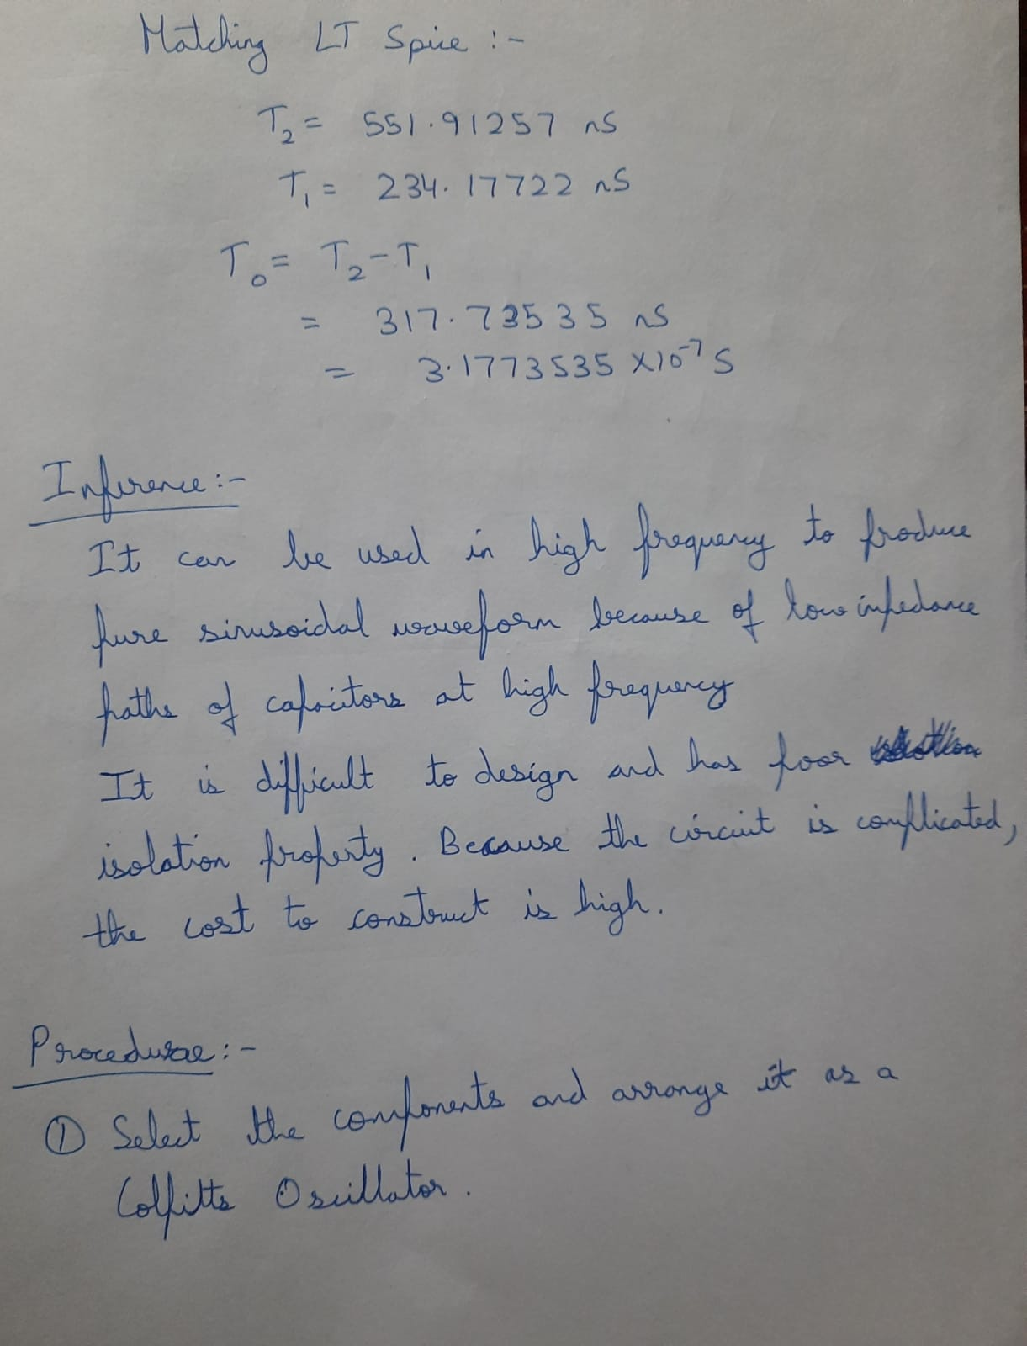

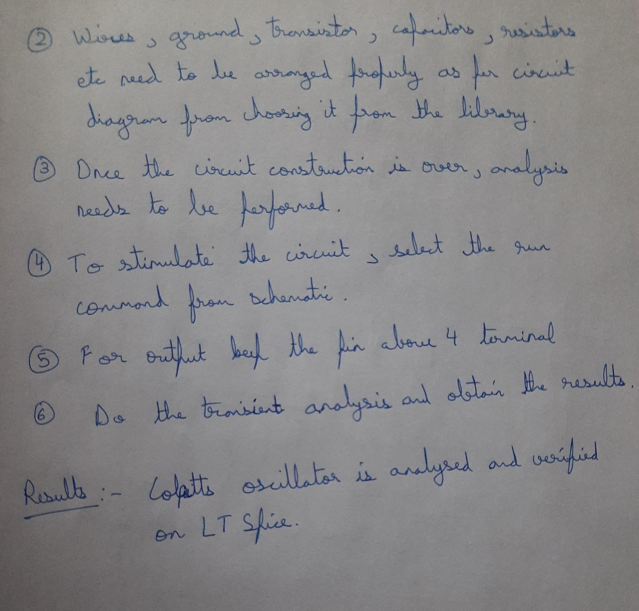

FINDING TO BY SUBTRACTING THE BACKWARD PEAK TIME FROM THE FORWARD PEAK TIME:

FORWARD PEAK TIME:

BACKWARD PEAK TIME:

